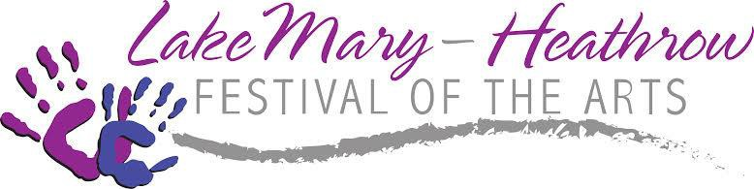

**SCHOLARSHIP APPLICATION 2025**

The Lake Mary Heathrow Festival of the Arts Scholarship awards $1,000 to one deserving graduate from each Seminole County Public High School who has shown an interest in the arts. Students must meet all the requirements. Scholarship award checks will be written to the institution the student plans to attend.

Completed application must be post marked by January 31, 2025 and returned to **The Scholarship Committee at P.O. Box 952125, Lake Mary, FL, 32795.**

Requirements:

* Submit a completed scholarship application
* Have a minimum of 3.0 GPA

Student’s Name: GPA: Parent’s Name: Address: City: , FL Phone: High School: Teacher in the Arts: Student email address: What college do you plan to attend? Accepted?

Intended major in college:

During the 2024-25 year, do you intend to be

* Full-time student?
* Part-time student?

Are you eligible for the Bright Futures Scholarship? yes no If yes, what level? Please submit the following with your application:

* + A list of your high school achievements, extracurricular activities and any arts awards.
  + A statement of your personal artistic goals and your potential contribution to the arts (minimum of 150 words.)
  + Submit a one paragraph statement of financial need.
  + Unofficial high school transcript which includes SAT and/or ACT scores.
  + Two letters of reference, one of which must be from your high school “arts” teacher written on school letterhead. References should include information regarding your artistic skills and commitment to the arts.

Student Signature:

**P.O. Box 952125 Lake Mary FL 32795-2125 407-444-0484 fax 407-833-8496**

[**www.LakeMaryHeathrowArts.com**](http://www.lakemaryheathrowarts.com/)[**info@LakeMaryHeathrowArts.com**](mailto:info@LakeMaryHeathrowArts.com)